

**Parent Handbook**

**2023-24**

*Revised: 9/13/2023*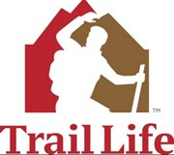

***Important Troop Information***

**Charter Organization**  East Pickens Baptist Church  
 2244 Gentry Memorial Hwy  
 Pickens, SC 29671

**Meeting Nights** 1st through 3rd Thursday of each month  
 from 6:30 - 8:00PM

Also meet on 5th Thursday as necessary

Navigators & Adventurers will also meet   
 on the 4th Thursday of each month to   
 complete additional work toward their   
 Freedom Award requirements.

**Membership Fees** Membership is paid to the TLUSA National   
 Organization directly through the Trail Life   
 Connect (TLC) website.

- Trailman membership = $33.25* Annually  
 - Adult membership = $38.00** Annually  
 *cost includes insurance coverage

**cost includes insurance coverage and a   
 criminal background check

**Troop Dues** $25 per Trailman (maximum of $50 per family)

Dues are paid directly to the troop via cash or check made payable to EPBC (East Pickens Baptist Church). We also accept Zelle, PayPal, or Facebook Messenger. See Susan Stewart for details if interested in one of these options.

**Contact Information** Daniel Graybeal, *Troopmaster*

Email: Traillifesc2244@gmail.com

Phone: 864.508.6901

Website: [www.traillifesc2244.com](http://www.traillifesc2244.com)

Trail Life Connect Login:

<https://www.traillifeconnect.com/login>

.

***Troop Leadership***

Senior Ministry Leader Brandon Helms

Troop Ministry Liaison Donnie Webb

Troop Master Daniel Graybeal

Asst. Troop Master/Woodlands Ranger Tony Maritato

Committee Chair Austin Barker

Treasurer/Secretary Susan Stewart

Chaplin Rusty Metts

**Committee Chairs**

Recruitment/Membership/Onboarding Susan Stewart

Training/ Health & Safety Chris Best

Activities Steve Leiphart

Community Service Tim & Maggie Boissy

Fund Raising ??

**Patrol Leadership**

Fox Patrol Trail Ranger Tony Maritato (Temp)

Fox Patrol Trail Guide

Hawks Patrol Trail Ranger Austin Barker

Hawks Patrol Trail Guide Phillip Stevens

Mtn Lions Patrol Trail Ranger ??

Mtn Lions Patrol Trail Guide Sam Bouter

Navigators Trail Master Mark Holder

Navigators Trail Guide Rusty Metts

Adventurers Advisor Brock Bailey

Adventurers Trail Guide Steve Leiphart

Parent Patrol Daniel Graybeal

***Patrol Levels***

**WOODLANDS TRAILS**:

* Fox Patrol - Kindergarten and 1st Grades
* Hawk Patrol - 2nd and 3rd Grades
* Mountain Lion Patrol - 4th and 5th Grades

**NAVIGATORS**: 6th through 8th Grade

**ADVENTURERS**: 9th through 12th Grade

**PARENT PATROL**: All parents/guardians of our Trailmen not actively involved in leading within the Troop.

***Behavioral Expectations at Meetings***

We understand and encourage boys to be boys, which means they are going to be high energy, and at times, unfocused. Yet, we expect each Trailman to show respect and courtesy to each member of the troop, both adult and Trailman. Each patrol always has a minimum of two adult leaders. Should unacceptable behavior occur, leaders may bring the Trailman or Trailmen involved to the Troopmaster for appropriate action. If the behavior continues, the Troopmaster will address the matter 1:1 with the parents to find a mutually agreeable solution that allows the Trailman to continue as an active and growing member of the troop. Our goal is for every Trailman to play an active role in the activities being done and to never have to handle behavior in the troop in this manner, but we want each troop member to understand what is expected of him as part of SC-2244.

***Attendance***

For Trailmen to complete branch or badge work, they need to attend all regular troop meetings whenever possible. To remain in good standing, they are required to attend at least 60% of the troop meetings and activities. Ultimately, missing meetings or activities will hurt the individual Trailman, but it will also impact the community and brotherhood that is developed among the patrols through regular meetings and the variety of activities they work on together.

***Makeup Activities***

A Woodlands Trailman may make up for one missed meeting per branch. Specific make-up activities are provided for making up the work missed in the meeting. We can only allow **one** make-up per branch to verify a Trailman has done what is required for each branch. **ATTENDANCE AT THE *HIT THE TRAIL* EVENT FOR EACH BRANCH IS REQUIRED IN ORDER TO EARN THAT BRANCH.** Only if parents notify their Woodlands leader ahead of time of their inability to attend and work out a suitable substitute will an exception to this requirement be made.

Ad/Navs make-up work is at the discretion of the Patrol Leader and must be scheduled accordingly with that leader.

***Expectations for Parents***

Trail Life USA is as much an opportunity for parents as it is for the boys who make up the troop. For the troop to be successful, we must have parent volunteers. Our expectation is that each family will have at least one parent volunteering in some capacity at meetings or in background roles supporting the troop’s success. If you are not sure where you can best serve the troop, please complete the inventory at the back of this handbook to help us better identify where you can serve.

We understand that some families have extenuating circumstances and parents may not be able to participate. If this is the case, please see the Troopmaster to come up with a plan for supporting your Trailman and other members of the troop. Ultimately, the troop will only be successful if we have volunteers/leaders willing to invest in the Trailmen. Without each parent’s involvement, the troop *will* experience burnout and will not be able to grow to accommodate all the new boys that may want to join in the future.

**We expect all parent volunteers to become Registered Adults**. To participate as a troop leader/helper, including at campouts and other troop trips, a parent must register with the national Trail Life organization as a *registered adult* via Trail Life Connect. Unless registered, parents cannot participate as patrol leaders/helpers, lead groups during camping activities or hikes, or oversee Trailmen at any time. This is to guarantee that no adult volunteer with a history of abuse or questionable legal background has an opportunity to harm one of our Trailmen. To date, the national TLUSA organization has never had a complaint against a troop for this type of issue. By requiring adults to register and complete a background check, we can ensure this continues to be a safe place for all the boys.

A Parent Patrol for all adults not involved in leading or otherwise supporting one of the youth patrols will be created each year and will function as an active patrol within the troop using the same “patrol method” as the youth patrols. This Parent Patrol will meet in a separate classroom to learn about Trail Life, the Patrol Method, and Trail Life Connect, as well as to discuss upcoming events and have individual questions answered. There will also be a *Wild at Heart Devotion* presentation. All parents will be asked to meet in this room rather than remaining in the theater to minimize distractions to the Trailmen. Thank you for your cooperation.

***Fundraising***

We don’t ever want money to keep a boy from being able to join our troop and participate in all the camping and learning opportunities our troop has each year. For this to be the case, we will need to hold fundraisers. As a troop, we will be holding ***four***troop-wide fundraisers per year. ***Each Trailman must pick two events per year***, (one per semester). Every member of the troop is expected to participate in fundraising. Troop-wide fund raising allows us to make larger purchases for the troop and help cover the costs of bigger experiences, such as high adventure activities, extended backpacking, summer adventures, or camping in a cave or battleship. A family may opt out of participating in a fundraiser by paying $30 per semester, per Trailman. (The Trailmen themselves should work to earn this cash-out.) If the Trailman fails to participate in the required fundraising events or pay the cash-out amount, unfortunately, they will not be approved for troop participation the following year until the balance is paid.

There are other peripheral fundraising opportunities to allow your Trailmen to earn more and save out of pocket expenses for the large troop-wide events. These will be discussed in the Parent Patrol meetings. Keep in mind that these extra opportunities do not negate the troop-wide fundraiser participation requirements.

***Fee and Uniform Payment Methods***

National membership fees are only payable electronically through the TLC Website. Local troop dues, uniform orders and other activity payments are made directly to the troop via cash or check made payable to EPBC (East Pickens Baptist Church). We also accept Zelle, PayPal, or Facebook Messenger. If you are interested in these options, see Susan Stewart for details.

***Uniform Requirements***

***Trailmen***

Trail Life USA (TLUSA) has a standardized Class A uniform for all Trailmen. Wearing the uniform identifies each Trailman as a member of a much larger organization, and the uniform becomes a point of pride for each member of TLUSA. The current price of the shirt is **$45**. The uniform is designed to be used until the Trailman outgrows it; therefore, only a select number of pieces ever become a permanent part of the uniform shirt.

One of the permanent items is a troop number patch that is sewn onto the right sleeve of each uniform shirt, ¼” below the shoulder seam. We have designed a customized SC-2244 troop patch, which costs **$5.**

Each patrol has specific shoulder epaulets which cost **$10**. As the Trailman moves up, he will need to purchase epaulets for the next patrol.

For a Trailman at the Mountain Lion or Ad/Nav level, a lanyard to display his TLUSA ID is also required. (The TLUSA ID is available on Trail Life Connect under a Trailman’s profile.) The lanyard costs **$5**.

So, the initial amount to outfit your Trailman will be **$55** for a Woodlands Fox or Hawk, or **$60** for a Woodlands Mountain Lion or Ad/Nav Trailman. After that, it will depend upon how quickly he outgrows a uniform shirt or changes a patrol. **NOTE: 6% SC sales tax will be added to all orders.**

The TLUSA store charges a flat rate for shipping, whether you order one item or many. So, to reduce shipping costs for everyone, the troop creates a bulk order each September and January. Order forms are handed out at the meetings, and the cutoff date for bulk orders will be the last troop meeting in September and January (unless otherwise communicated). Payments must be given to the troop treasurer by the identified deadline. If you have not **placed your order and paid for it** by that date, you will be required to place your order individually through the TLUSA Store. <https://shop.traillifeusa.com/> and will incur shipping fees of $9.99 per order.

Our troop does not ask the Trailmen to purchase the official uniform pants. The pants offered in the TLUSA store are expensive and sometimes do not fit the boys well. We ask each Trailman to have a pair of **clean and well-kept khaki shorts** (for warm weather) **or pants** (for cold weather) to wear with his uniform shirt. This is especially important if he is representing the troop at a community event.

*Formal color guard members (only Navigators & Adventurers) will be asked to provide a well-kept dark green pair of pants that are closer to the official TLUSA pants, though we do not dictate what brand, since they need to find what fits them best.

***Adults*** *If possible, we ask that all patrol leaders wear the official polos or T-shirts appropriate to their patrol.* These are not a requirement but help to easily identify the leaders for all parents, especially new families that might be attending. Adult leaders may also purchase an official Class A uniform shirt if they desire to do so. **All adult leaders are *required* to have their TLUSA lanyard and ID on them if they are working with the Trailmen.** This helps us to ensure that only registered adults are in direct contact with the boys. Adult Class A uniform shirts are $45, the same as Trailmen shirts. Official polos and T-shirts vary quite a bit, so if you want to buy one of those, please go to the website and make your choice. We can still include your shirt as part of our bulk order, but you will need to identify what you want by going to the website:

Dress shirts/polos: [Dress Shirts and Polos Archives - Trail Life USA](https://shop.traillifeusa.com/shop/youth-and-mens-apparel/dress-shirts-and-polos/)

T-Shirts: [T-Shirts Archives - Trail Life USA](https://shop.traillifeusa.com/shop/youth-and-mens-apparel/t-shirts/)

*Examples of the TLUSA uniforms*

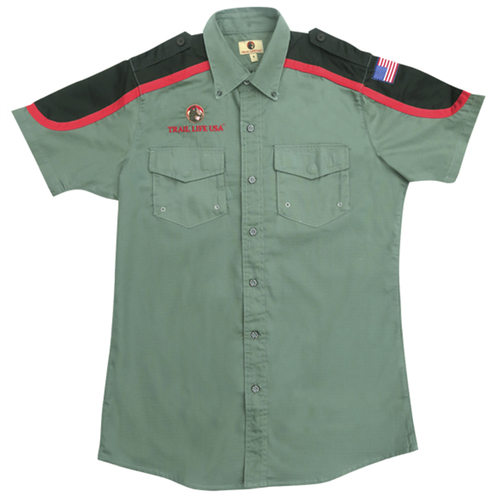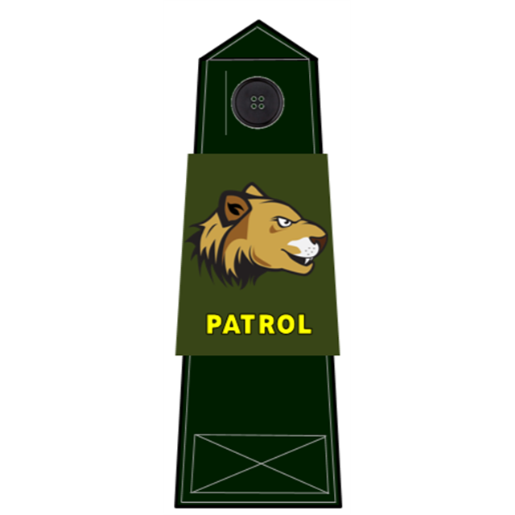

*Class A Uniform Shirt Shoulder Patrol Epaulet*

*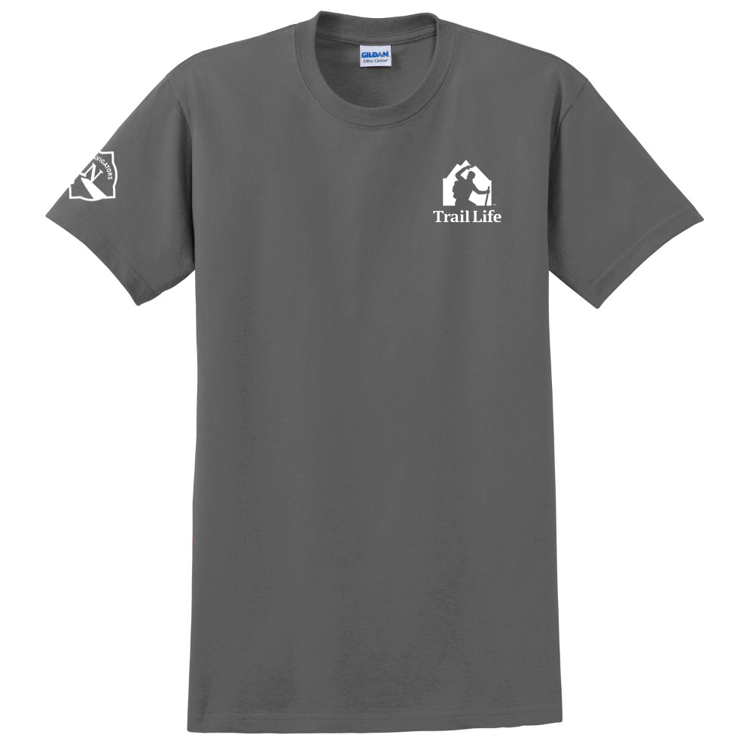***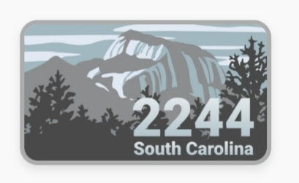** Adult Patrol t-shirt Troop number patch (custom to SC-2244)

***Medical Forms***

Trail Life requires each Trailman and adult volunteer to complete an updated medical history form at the start of each program year. The form must be completed and turned in to the Troopmaster prior to being allowed to participate in any activities outside of regular troop meetings. Once Trailmen reach the Navigator level, they will also be asked to complete a high-adventure form. This allows them to participate in extended camping, backpacking, or other troop trips. Without these forms on file your son will not be allowed to attend any events outside of the regular troop meetings, because they are required for coverage under Trail Life’s insurance policy. Therefore, if you plan to attend an outing with your son, you must complete one of these forms as well, even if you are not a leader. These forms will be kept in a troop notebook and will be carried on all troop trips.

All required medical forms will be provided to you at the first meeting of the year and are also available on Trail Life Connect, the troop website. [View User (traillifeconnect.com)](https://www.traillifeconnect.com/profile?tab=resources&tab=resources&tag_id_resources=ugrgmdda99b2)

Beginning in the 2023-24 year, these forms are linked to your sign-up for an outing and can be filed electronically. (More about that in your Parent Patrol Meeting!)

***Training***

We understand that not all parents have scouting in their backgrounds. To help with this, the Trail Life Organization offers various training sessions for parents as well as troop volunteers.

Most notably, we would like to encourage everyone to attend a **Trail Ready Learner Conference,** which will help you understand why we do what we do in Trail Life and how you fit into the big picture. We will let you know when the next one in our area is to be held.

The **3-Peaks Training** sessions are intended to train Trail Life Leaders, but they are great resources for anyone who would like to become familiar with the structure and operation of Trail Life, or to experience first-hand the Patrol Method that is at the core of our program. Peak 1 and Peak 2 are offered both online and in person. The online version, through Trail Life Connect, can be done at your own pace and to the extent of your interest. Peak 3 is a weekend of camping that provides hands-on experience and training and is not available in an online format.

We will also provide opportunities for our troop leadership and volunteers to receive training and support at annually-scheduled training. *We highly recommend you take advantage of these opportunities as they will help you to have a much deeper understanding of the purposes and structures within Trail Life, which will increase your appreciation for the value of this organization*. All these training opportunities will be further discussed during the Parent Patrol meetings.

